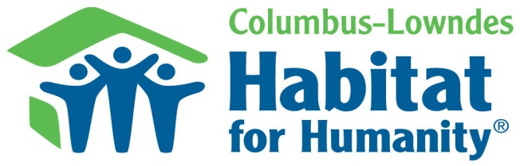
Pre-Application
Screening
A first step to owning your own home
Do you have a legitimate housing need? (Please check all that apply)
Health hazards Section 8/Public Housing High crime/drugs area Overcrowding
Mobile home Maintenance Problems Homelessness Inefficient
Yes No Are you and/or family & friends willing to work 300 hours to help build your home?
Yes No Is your credit good or repairable?
Yes No Have you filed bankruptcy in the last 12 months?
If yes, it will take longer to become eligible for a home. When filed? _____________________________________
Yes No Do you have any liens or judgments against you?
If yes, details: _____________________________________________________________________________________
Yes No Do you have bills turned over to a collection agency?
If yes, details: _____________________________________________________________________________________
Yes No Can you save $1,000 for a down payment within 12 months?
Yes No Do you currently own the home you are living in? _______
If not, how much is your rent? _______
Yes No Are you a US Citizen or permanent resident (green card)?
Number in household: __________ Adults _________ Children
How long have you lived in Lowndes county? __________ years
My family’s monthly gross income: _____________ (See guidelines p.2) Employer(s) ___________________
Include Social Security, Disability, Child Support, Alimony, Wages, Earned Income Tax Credit, & any other income for all wage earners.
List ALL debts owed, payments, and length of time remaining on loan for both Applicant and Co-Applicant:
_______________________________________________________________________________________
_______________________________________________________________________________________
_______________________________________________________________________________________
_______________________________________________________________________________________
_______________________________________________________________________________________

Applicant Co-Applicant
Name: ______________________________________ Name: ________________________________________
Address: ____________________________________ Address: ______________________________________
City/State/Zip: ______________________________ City/State/Zip: ________________________________
Home Phone: ________________________________ Home Phone: __________________________________
Work Phone: ________________________________ Work Phone: __________________________________
Cell Phone: __________________________________ Cell Phone: ____________________________________
E-mail: ______________________________________ E-mail: ________________________________________

How does
Habitat work?

What is Habitat for Humanity?
Columbus-Lowndes Habitat for Humanity (CLHFH) is a not-for-profit, Christian ministry that builds homes in partnership with low-income families. Volunteers join partner families in building their homes. Families repay Habitat by making monthly payments on an affordable mortgage. CLHFH makes no profit.

Who qualifies for a habitat home?
Successful applicants for home must:
1) Have a problem with their current housing such as overcrowding, housing in bad condition, unsafe neighborhood, etc.
2) Have been unable to secure and/or maintain a conventional mortgage.
3) Have a low, but steady, earned income.
4) Be willing to work on their own home as well as on other Habitat projects.
5) Before taking ownership of your home, you must volunteer a total of 300 hours.
6) Have the ability to repay Habitat for the cost of the home by means of monthly mortgage payments.

Financial qualifications
Persons in Family | Minimum Annual Income | Maximum Annual Income | Maximum Monthly
1 | $11,640 | $31,050 | $2,587
2 | $13,320 | $35,450 | $2,954
3 | $14,970 | $39,900 | $3,325
4 | $16,620 | $44,300 | $3,691
5 | $17,970 | $47,850 | $3,987
6 | $19,290 | $51,400 | $4,283
7 | $20,610 | $54,950 | $4,579
8 | $21,960 | $58,500 | $4,875
Include Social Security Income, Disability, Child Support, Alimony, Wages, Earned Income Tax Credit, & any other income for all wage earners. Above are just guidelines. Families falling slightly outside of these income requirements may still be eligible.

We help you help yourself
CLHFH offers a hand up, not a hand out. Families are expected to work alongside other volunteers in planning and building. Potential homeowners may be required to attend financial management classes, and learn how to maintain a home so they will be prepared for ownership.

What does a habitat house cost?
The average home costs between $50,000- $75,000. Monthly mortgage payments are $275.00-450.00. Owners must also pay into an escrow account for property taxes and home insurance, averaging about $100 - $150. The monthly payment will not exceed 30% of gross family income. Mortgages are based on the actual cost of the home.

How long will it take to get a house?
The length of time depends on the speed with which applicants complete sweat equity hours, the number of applicants, the relative needs of those in our applicant pool, the number of volunteers available for construction, and other factors.

What is the next step?
If you’re interested and think you qualify, fill out a pre-application screening form. Contact clhfh@cableone.net or call 662-329-2501 with questions. You will be contacted by a Habitat volunteer within three weeks after receipt of your pre-application.

Columbus-Lowndes Habitat for Humanity
The local affiliate of Habitat for Humanity International has been active since 1989 in the Lowndes County area. CLHFH is Christian but not affiliated with any denomination. We do business in accordance with the federal fair housing laws. Race, color, religion, sex, handicap, familial status, national origin and social and economic status have no bearing on eligibility for home ownership.

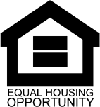

Contact clhfh@cableone.net
662-329-2501
Columbus-Lowndes Habitat for Humanity
1110 Gardner Blvd., Columbus, MS 39702

